Prior Knowledge

|  |  |
| --- | --- |
| **DATE** | **08 November 2022** |
| **Team id** | PNT2022TMID29241 |
| **Project Name** | **Emerging methods for early detection of forest fires** |

# Supervised and unsupervised learning:

## Supervised Learning

The machine learns under supervision. It contains a model that is able to predict with the help of a labelled dataset. A labelled dataset is one where you already know the target answer.

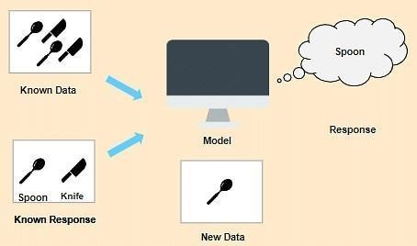

In this case, we have images that are labelled a spoon or a knife. This known data is fed to the machine, which analyses and learns the association of these images based on its features such as shape, size, sharpness, etc. Now when a new image is fed to the machine without any label, the machine is able to predict accurately that it is a spoon with the help of the past data.

## Supervised learning can be further divided into two types:

* In Classification
* Regression

## Unsupervised Learning

The machine uses un-labelled data and learns on itself without any supervision. The machine tries to find a pattern in the un-labelled data and gives a response.

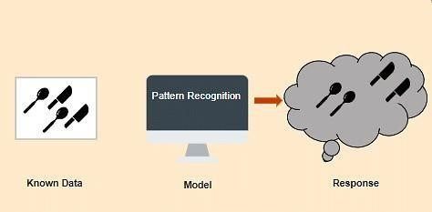

Let's take a similar example is before, but this time we do not tell the machine whether it's a spoon or a knife. The machine identifies patterns from the given set and groups them based on their patterns, similarities, etc.

## Unsupervised learning can be further grouped into types:

* Clustering
* Association

# Regression, Classification and Clustering:

**Regression** is used when the output variable is a real or continuous value. In this case, there is a relationship between two or more variables i.e., a change in one variable is associated with a change in the other variable. For example, salary based on work experience or weight based on height, etc.

**Classification** is used when the output variable is categorical i.e. with 2 or more classes. For example, yes or no, male or female, true or false, etc. In order to predict whether a mail is spam or not, we need to first teach the machine what a spam mail is. This is done based on a lot of spam filters - reviewing the content of the mail

reviewing the mail header, and then searching if it contains any false information. Certain keywords and blacklist filters that blackmails are used from already blacklisted spammers.

**Clustering** is the method of dividing the objects into clusters that are similar between them and are dissimilar to the objects belonging to another cluster. For example, finding out which customers made similar product purchases. Suppose a telecom company wants to reduce its customer churn rate by providing personalized call and data plans. The behaviour of the customers is studied and the model segments the customers with similar traits. Several strategies are adopted to minimize churn rate and maximize profit through suitable promotions and campaigns.

# Artificial Neural Networks:

Artificial Neural Network Tutorial provides basic and advanced concepts of ANNs. Our Artificial Neural Network tutorial is developed for beginners as well as professions. The term "Artificial neural network" refers to a biologically inspired sub-field of artificial intelligence modelled after the brain. An Artificial neural network is usually a computational network based on biological neural networks that construct the structure of the human brain. Similar to a human brain has neurons interconnected to each other, artificial neural networks also have neurons that are linked to each other in various layers of the networks. These neurons are known as nodes.

# Convolution Neural Networks:

Convolutional Neural Networks are a special type of feed-forward artificial neural network in which the connectivity pattern between its neuron is inspired by the visual cortex. The visual cortex encompasses a small region of cells that are region sensitive to visual fields. In case some certain orientation edges are present then only some individual neuronal cells get fired inside the brain such as some neurons responds as and when they get exposed to the vertical edges, however some responds when they are shown to horizontal or diagonal edges, which is nothing but the motivation behind Convolutional Neural Networks.